Orphanage Website

# Overview:

**This project showcases the use of HTML, CSS and Javascript for creating a website. The website is that of an orphanage which takes care of orphan children. The website contains pages for donation, adoption, gallery and home page.**

### Bootstrap components used in project:

* **Carousel**
* **Form**
* **Rows and Columns**
* **Navbar**
* **Modal**
* **Drpdown**

### HTML concepts used:

* **Meta tags**
* **External CSS**
* **External JS**
* **Media integration – Image, Video**
* **Division and span tags**
* **Open tag – Break line**
* **Special Character element**

### CSS concepts used:

* **Inline Styling**
* **External Font APIs**
* **CSS Selectors**

### Javascript concepts used:

* **Functions**
* **Document object**
* **Event Listener for form button click**

# Web Pages:

**Home Page:**

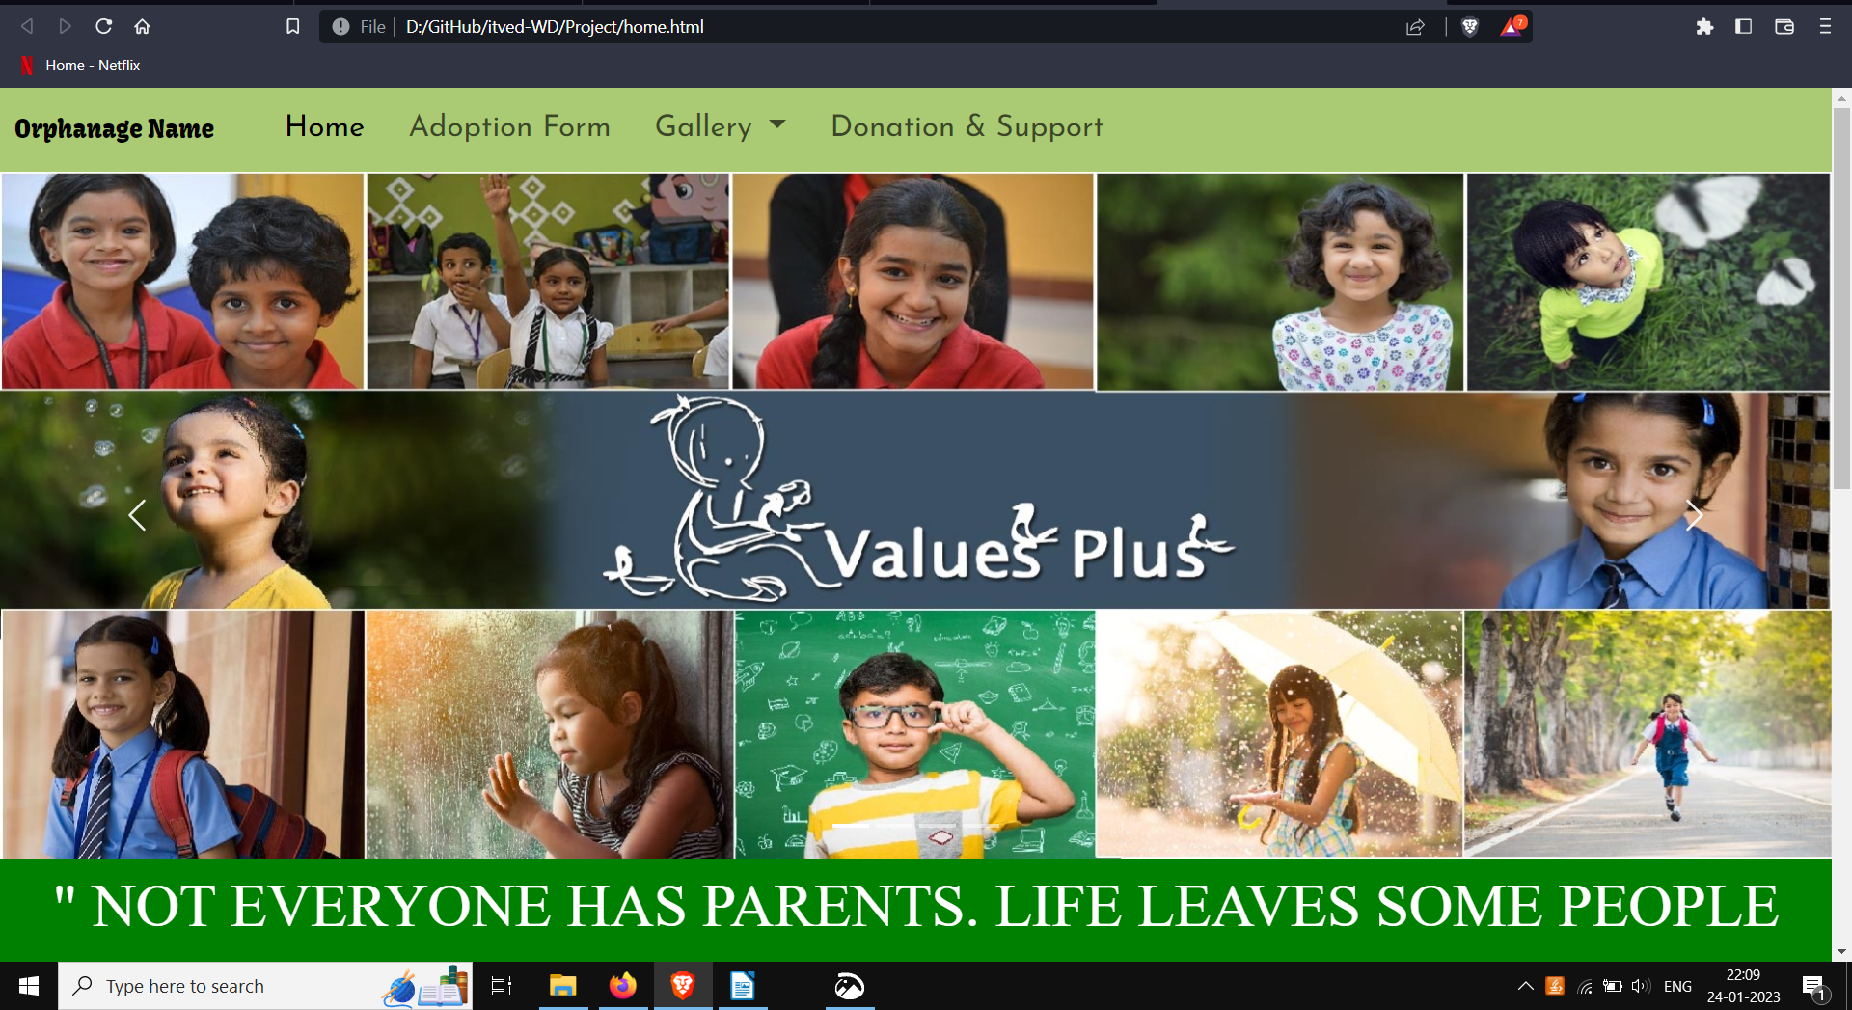

**Donation:**

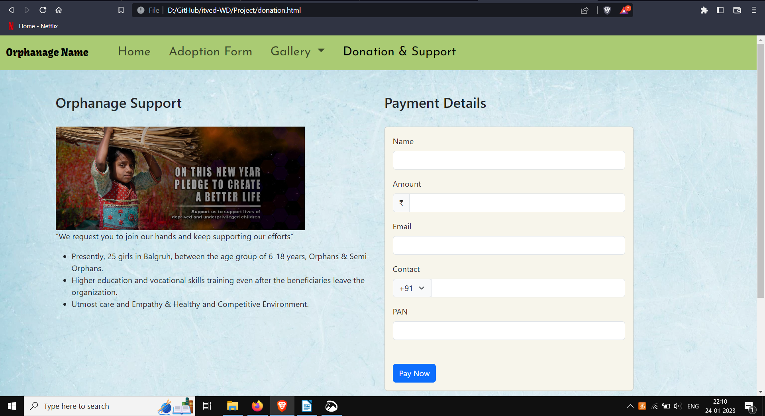

**Gallery:**

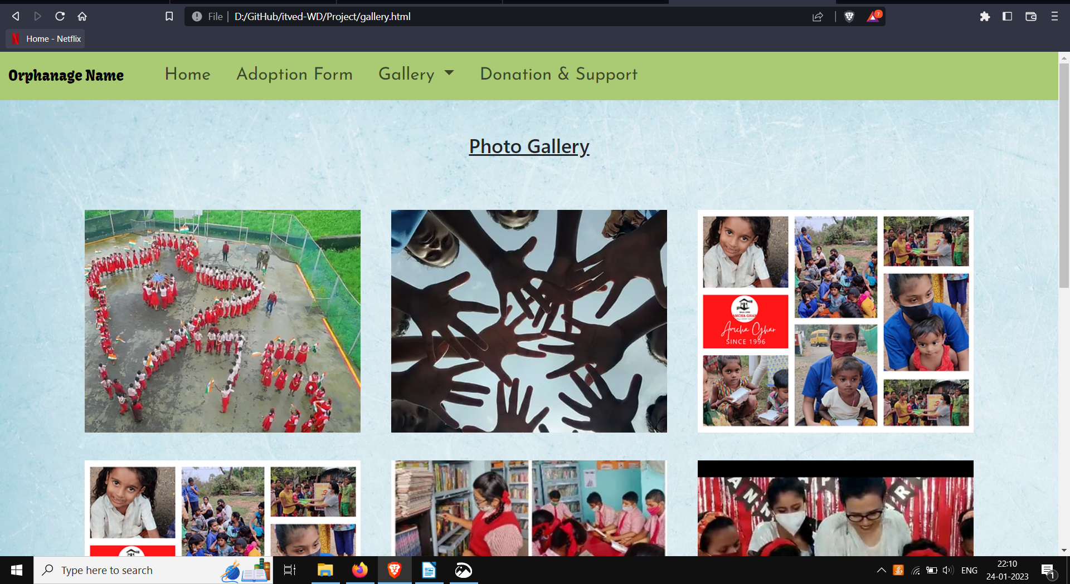

**Adoption:**

